**WEEK -2**

**SUPERSET ID: 6384042**

**TDD using JUnit5 and Mockito**

**1. JUnit_Basic Testing Exercises**

**Exercise 1: Setting Up Junit**

**om.xml**

<dependency>

<groupId>junit</groupId>

<artifactId>junit</artifactId>

<version>4.13.2</version>

<scope>test</scope>

</dependency>

**Code:**

public class Calculator {

public int add(int a, int b) {

return a + b;

}

}

**CalculatorTest.java**

import org.junit.Test;

import static org.junit.Assert.*;

public class CalculatorTest {

@Test

public void testAdd() {

Calculator calc = new Calculator();

int result = calc.add(2, 3);

assertEquals(5, result);

}

}

**OUTPUT:**



**Exercise 3: ASSERTIONS IN JUNIT**

**AssertionsTest.java**

import org.junit.Test;

import static org.junit.Assert.*;

public class AssertionsTest {

@Test

public void testAssertions() {

assertEquals("Sum should be 5", 5, 2 + 3);

assertTrue("5 is greater than 3", 5 > 3);

assertFalse("5 is not less than 3", 5 < 3);

assertNull("Object should be null", null);

assertNotNull("Object should not be null", new Object());

}

}

**OUTPUT:**

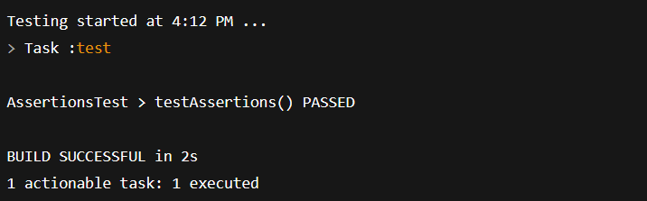

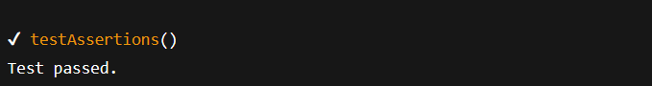

**Exercise 4: Arrange-Act-Assert (AAA) Pattern, Test Fixtures, Setup and Teardown Methods in Junit**

**Calculator.java**

public class Calculator {

public int add(int a, int b) {

return a + b;

}

public int subtract(int a, int b) {

return a - b;

}

}

**CalculatorTest.java**

import org.junit.Before;

import org.junit.After;

import org.junit.Test;

import static org.junit.Assert.*;

public class CalculatorTest {

private Calculator calculator;

@Before

public void setUp() {

System.out.println("Setting up test environment...");

calculator = new Calculator();

}

@After

public void tearDown() {

System.out.println("Cleaning up after test...\n");

calculator = null;

}

@Test

public void testAdd() {

int result = calculator.add(10, 5);

assertEquals("10 + 5 should be 15", 15, result);

}

@Test

public void testSubtract() {

int result = calculator.subtract(10, 5);

assertEquals("10 - 5 should be 5", 5, result);

}

}

**OUTPUT:**

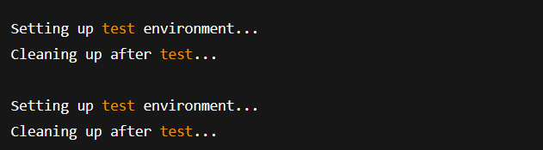

**3. MOCKITO EXERCISES**

**Exercise 1: MOCKING AND STUBBING**

public interface ExternalApi {

String getData();

}

**Service class**

public class MyService {

private ExternalApi api;

public MyService(ExternalApi api) {

this.api = api;

}

public String fetchData() {

return api.getData();

}

}

**Test class**

import org.junit.jupiter.api.Test;

import static org.junit.jupiter.api.Assertions.assertEquals;

import static org.mockito.Mockito.*;

public class MyServiceTest {

@Test

public void testExternalApi() {

ExternalApi mockApi = mock(ExternalApi.class);

when(mockApi.getData()).thenReturn("Mock Data");

MyService service = new MyService(mockApi);

String result = service.fetchData();

assertEquals("Mock Data", result);

}

}

**OUTPUT:**

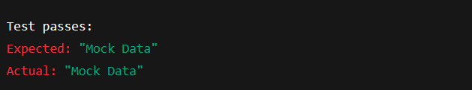

**Exercise 2: VERIFYING INTERACTIONS**

public interface ExternalApi {

String getData();

}

**Service class**

public class MyService {

private ExternalApi api;

public MyService(ExternalApi api) {

this.api = api;

}

public String fetchData() {

return api.getData();

}

}

**Test class**

import org.junit.jupiter.api.Test;

import static org.mockito.Mockito.*;

public class MyServiceTest {

@Test

public void testVerifyInteraction() {

ExternalApi mockApi = mock(ExternalApi.class);

MyService service = new MyService(mockApi);

service.fetchData();

verify(mockApi).getData();

}

}

**OUTPUT:**

